**Procedure to Flash FutureDial NFC Tags**

**Steps to Flash FutureDial NFC Tags:**

1. **Download and Install the app to flash the NFC tag for our customers**
2. Navigate to Local server, ‘\\10.1.1.27\Release\NFC-Auto-ADB’
3. Download ‘TagWriter_181129.apk’ file from the folder on Android phone.
4. After downloading the .APK file to Android phone, install it. The name of the installed app will be ‘NFCProvisioning’.
5. Using PC browser log into fsmc.futuredial.com with the following credentials:

* **Read only user:** Username: fsmcrnu

Password: r26u

Read only access can only view and download files from the server.

* **Write access user:** Username: fsmcwu

Password: w78u

Write access user can upload or remove .CSV file and .APK file.

File name convention for .CSV File: ‘CompanyName’_’SiteName’_’Date’.CSV

1. After logging in select ‘Files’ Tab, and check if the .APK file you want to flash on NFC Tag is present in the list of Files. **Until further notice only use ‘22.apk’.**

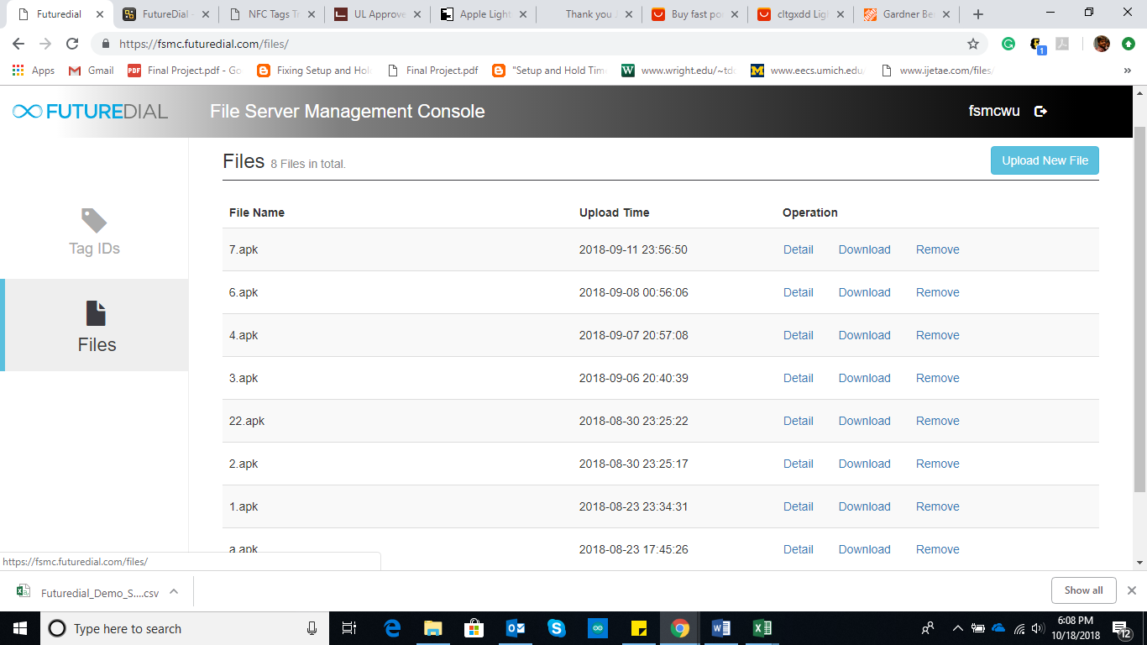

1. **Create .CSV File and Upload to File Server Management Console**
   * + 1. Create a .CSV file and fill the details such as **5-digit** Tag ID, App Name, Config, Company ID and Site ID as shown in the example below.

**Note:** If Tag ID is 00001, convert Excel column A to Text format and enter ‘00001’. It won’t work if ‘1’ set as Tag ID.

**Config is only ‘{}’, no space between braces.**

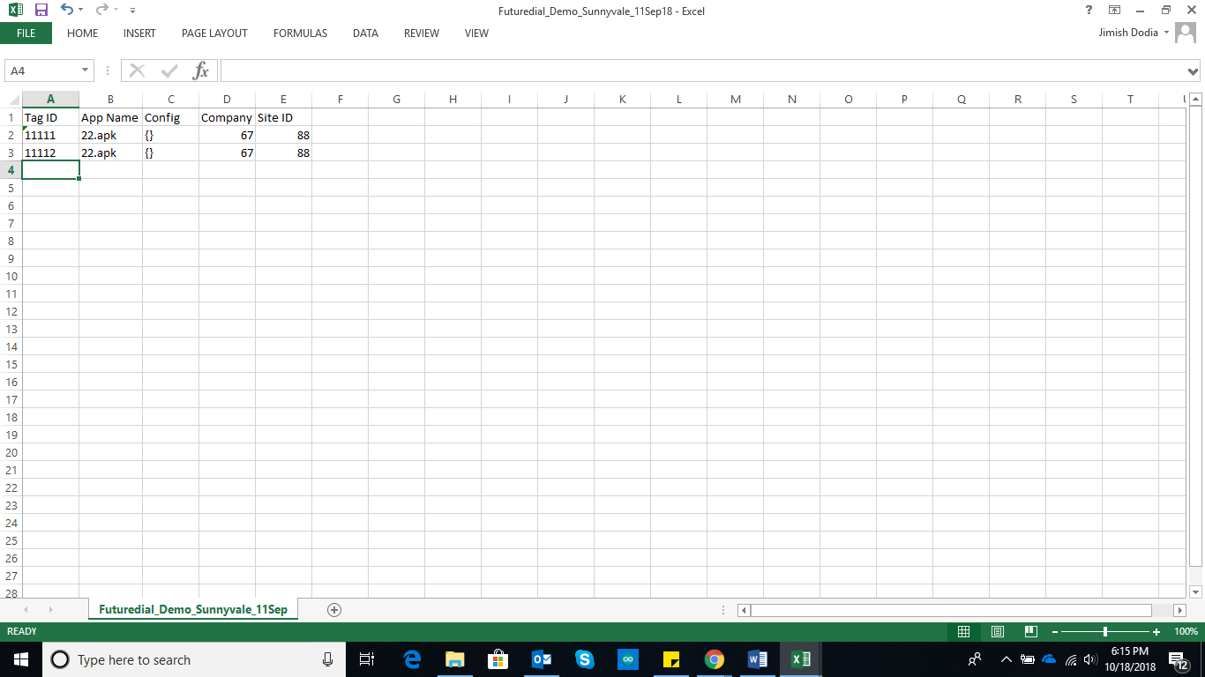

* + - 1. Get Company ID and Site ID from cmc.futuredial.com
      2. You can fill multiple Tag IDs with different App names in one .CSV file. Try to keep one .CSV file for each Company or Site within the Company.
      3. Save the .CSV File and upload it to fsmc.futuredial.com.

**File name convention for .CSV File:** ‘CompanyName’_’SiteName’_’Date’.CSV

* + - 1. After logging into fsmc.futuredial.com, select ‘Tag IDs’ Tab.

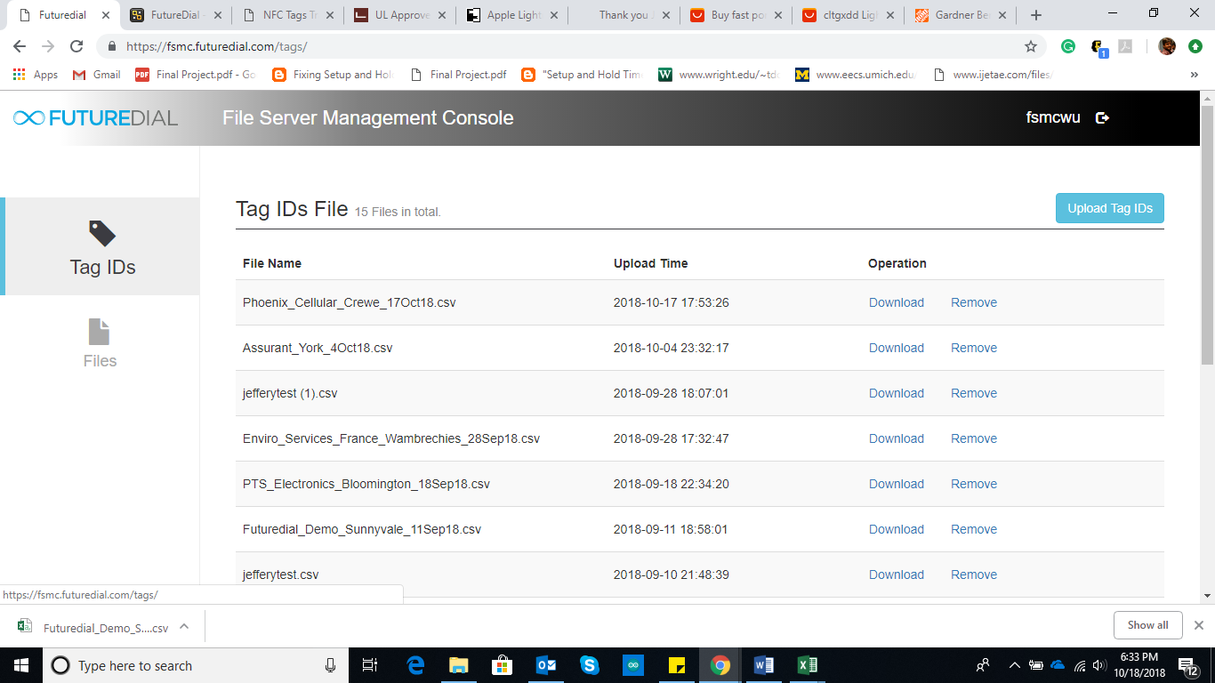

* + - 1. Click on ‘Upload Tag IDs’.



* + - 1. Select .CSV file to upload from local machine and click ‘Open’ to upload file to server.

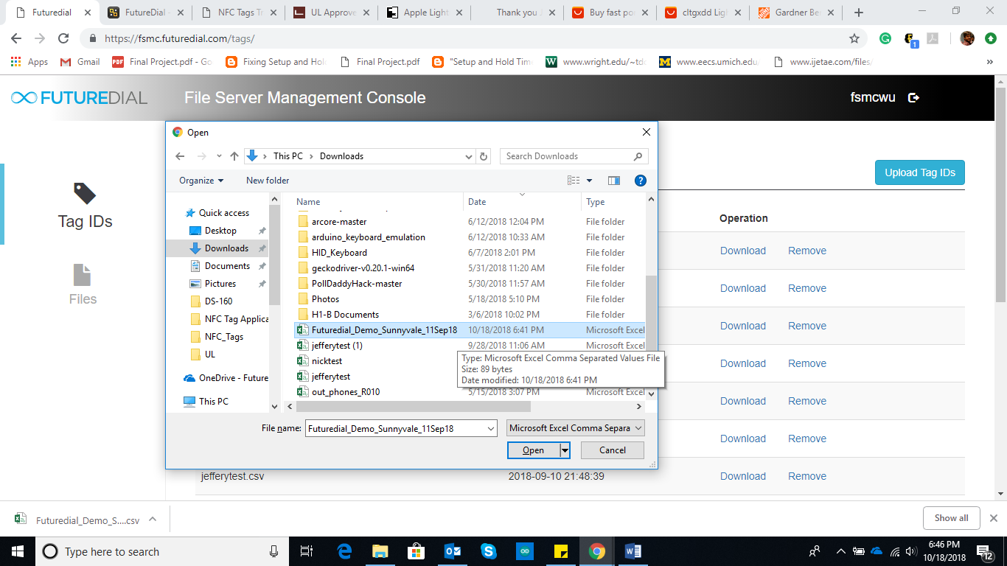

1. **Launch app and Program NFC Tag**

Launch ‘NfcProvisioning’ app on Android phone.

Fill all the parameters as shown in example given below,

* WiFi SSID
* Check box if hidden network, leave unchecked if not hidden.
* WiFi security type (WPA, etc.)
* Password
* Company ID (get from cmc.futuredial.com)
* Site ID (get from cmc.futuredial.com)
* NFC Tag ID (NFCId)
* Enter the server link from where the app will be downloaded. If it is a local server enter local server IP address.
* App name present in ‘Files’ tab of fsmc.futuredial.com. (This will go on NFC Tag)

**Until further notice only use ‘22.apk’.**

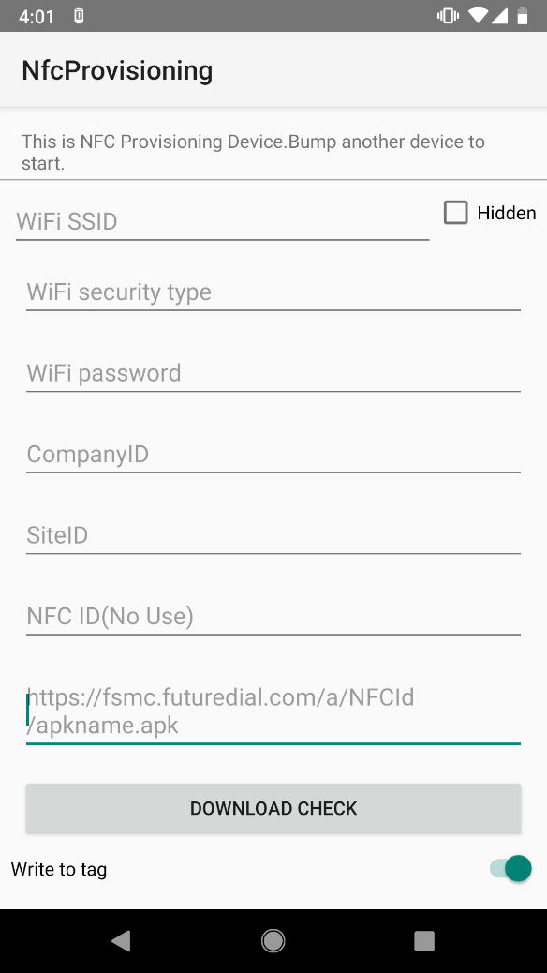 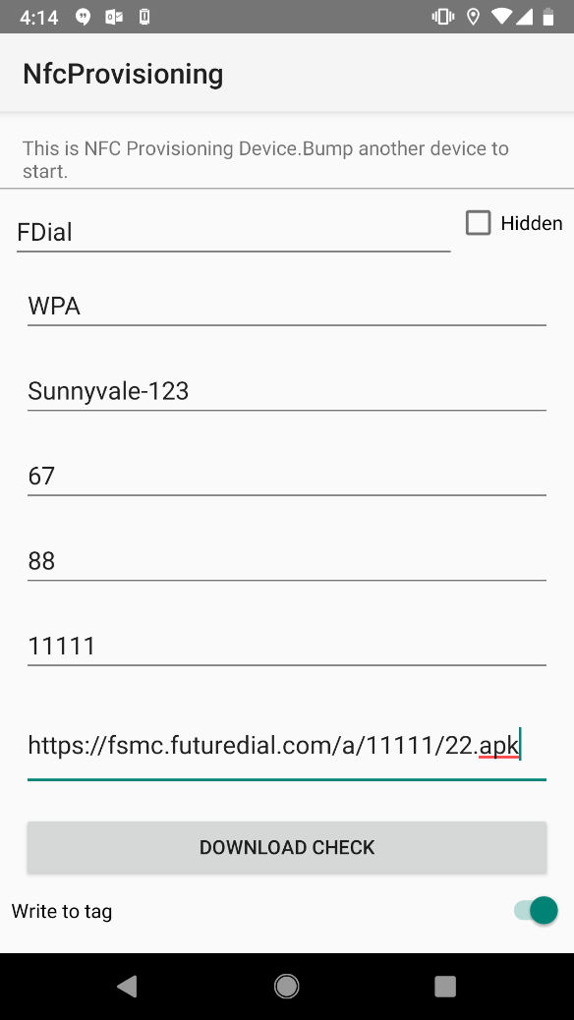

**Initial Page After filling all Fields**

If it is the first time you run this app on a phone, tap ‘DOWNLOAD CHECK’.

Keep ‘Write to Tag’ button ON.

Move phone on a NFC tag and hear the “beep” sound and wait until the phone prompts ‘Message Written’ on the screen. Then the tag is flashed.

Using a phone which is factory reset and on the Welcome screen, tap it on the NFC Tag you just flashed.

Follow steps on the phone screen until you are on the home screen.

Android ADB will be automatically enabled on the phone.